Siphesande Mnqonywa

SALES CASE Study METHODOLOGY

Contents

1. Objective 1

2. Tools used for Analysis 1

3. Formulas used for the project 1

4. Methodology 2

1. Data quality check 2

4. The Metrics 5

5. The Insights 12

## Objective

This case study is to analyze the sales performance of a single product in a retail store using business metrics. The goal is to derive meaningful insights that can help the store make data-driven decisions about pricing, promotions, and profitability

## Tools used for Analysis

* Python
* Microsoft Excel

## Formulas used for the project

* **Daily Sales Price Per Unit** =
* **Average Unit Sales Price** =
* **Daily Gross Profit (%)** =
* **Gross Profit Per Unit (%)** =
* **PED** =

## Methodology

### Data quality check

#### Checking the shape

To understand the number of rows and columns.

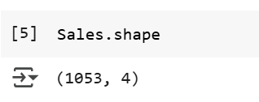

#### Checking statistics summary

To get summary statistics for numerical columns

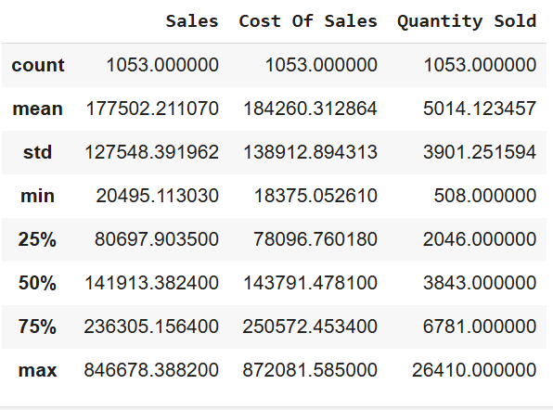

#### Checking the duplicates

To identify duplicate rows

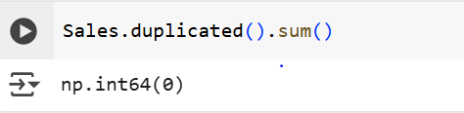

#### Checking data types

Ensure each column has the correct data type.

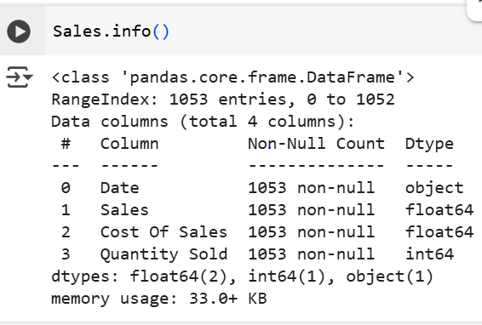

#### Checking Nulls

Identify missing values.

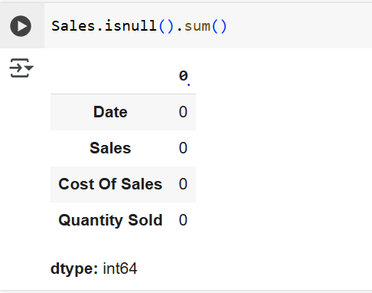

#### Checking distribution

Understand how data is distributed for numerical.

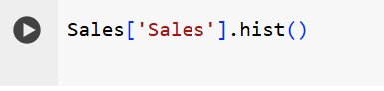 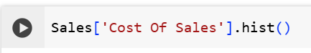 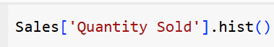

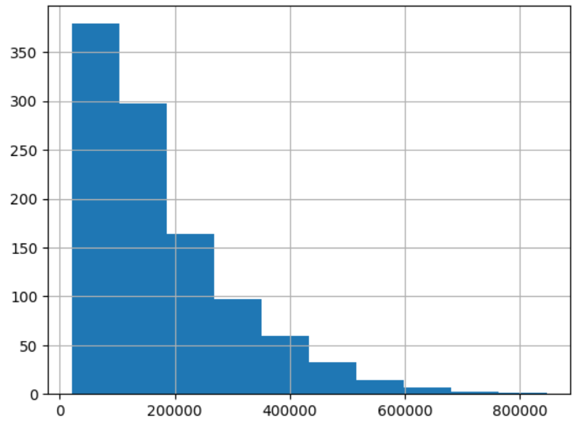 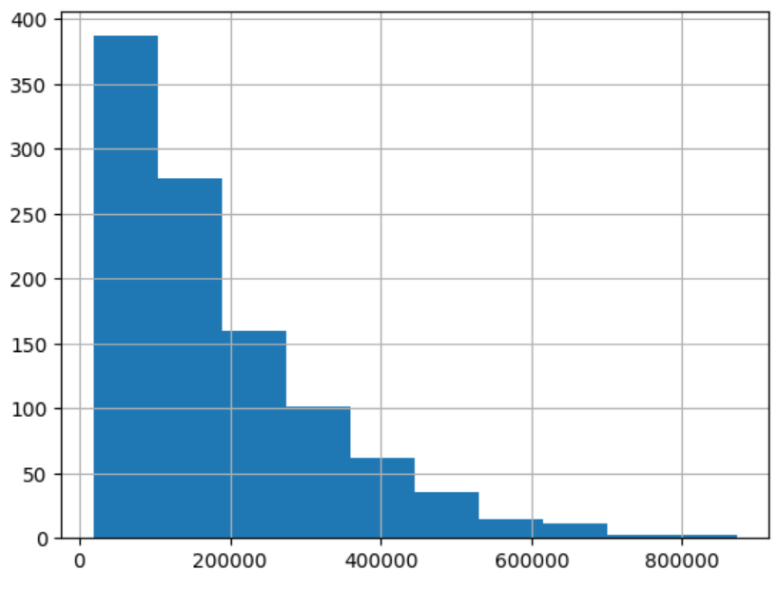 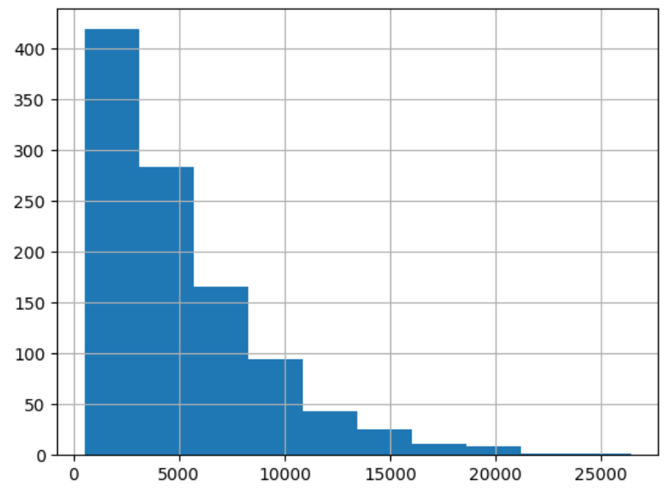

#### Checking Correlations

Identify relationships between numeric features.

The correlation efficient is (1,099) and it indicates that there is a **very strong positive linear relationship between the columns( features)**

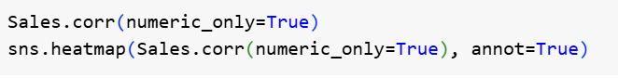

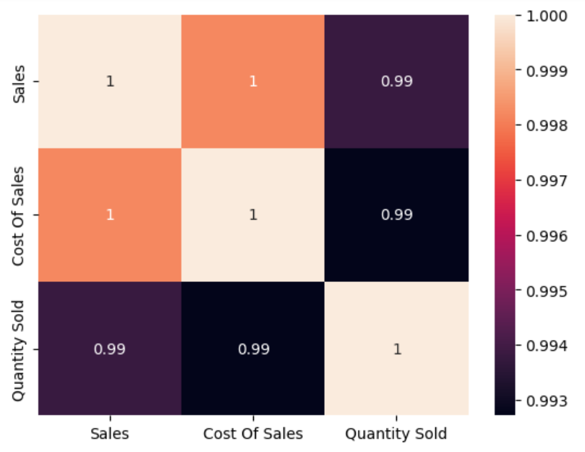

#### Checking Date Ranges & Consistency

To ensure there are no unexpected gaps or incorrect date formats



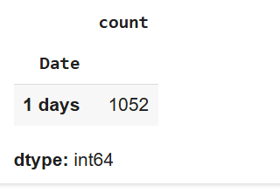

#### Checking for Business Logic Issues

Identify data entries that don’t make sense (e.g., negative sales or future dates)

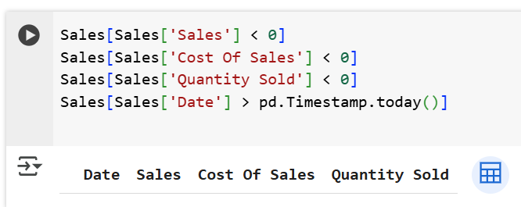

### 4. The Metrics

##### **Daily Sales Price Per Unit**

The price at which a single unit of a product is sold on a particular day

**Daily Sales Price Per Unit** =

The daily unit price has been fluctuating because of Promotions, discounts and other external factors however it went up from R32.80 in 2013 to R43.81 in 2016. The upward trend suggests that despite fluctuations, the overall pricing strategy allowed for an increase in unit sales price

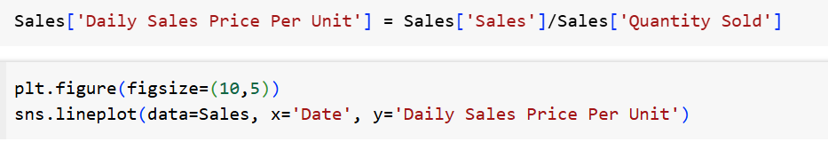

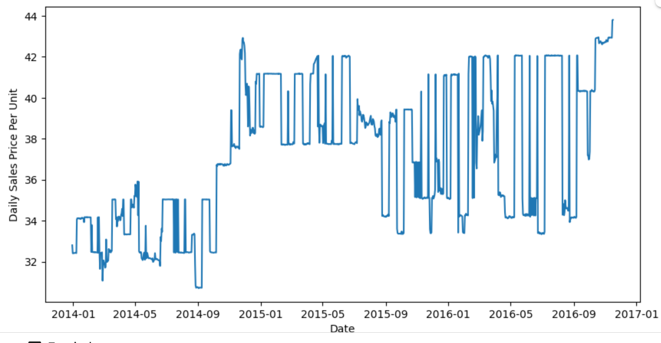

Showing First 5 and Last 5 records

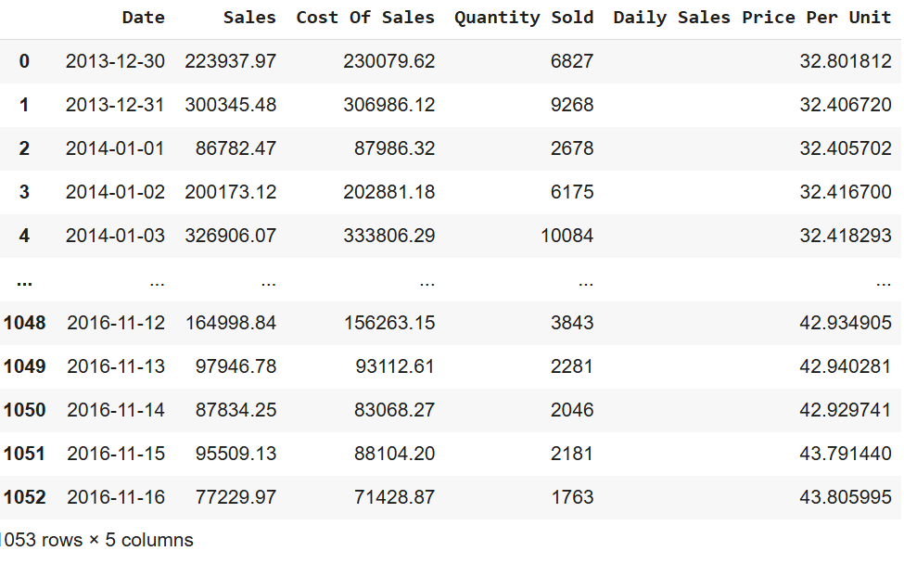

##### **Average Unit Sales Price**

The average price at which a single unit of a product is sold over a specific period.

**Average Unit Sales Price** =

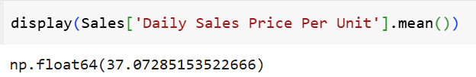

##### **Daily Gross Profit (%)**

This measures the profitability of sales on a given day. It shows how much of the revenue remains after covering.

**Daily Gross Profit (%)** =



Showing First 5 and Last 5 records

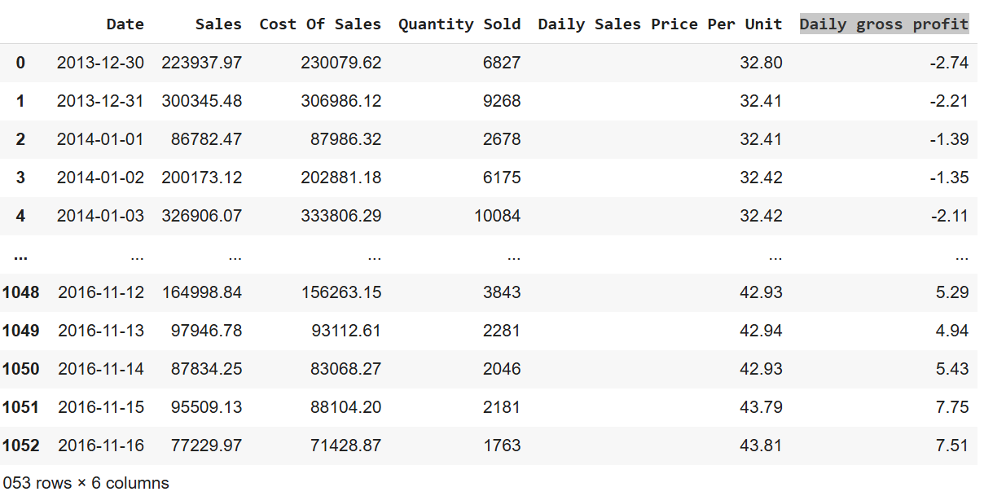

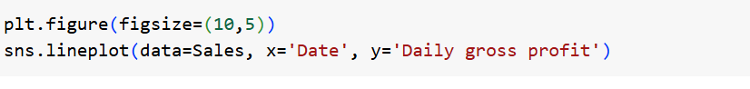Daily gross profit changed significantly over the days, even showing a quite number of negative values which is not good for the business. This usually happens due to excessive discounts, cost price increases, or operational inefficiencies.

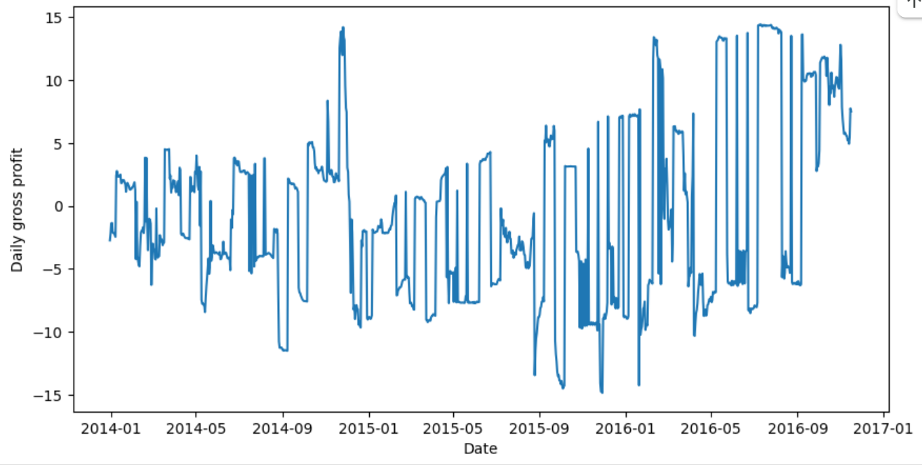

##### **Daily Gross Profit Per Unit (%)**

Itmeasures the profit margin made on each unit sold, expressed as a percentage of the selling price.

**Gross Profit Per Unit (%)** =





The daily gross profit per unit is the same as Daily gross profit

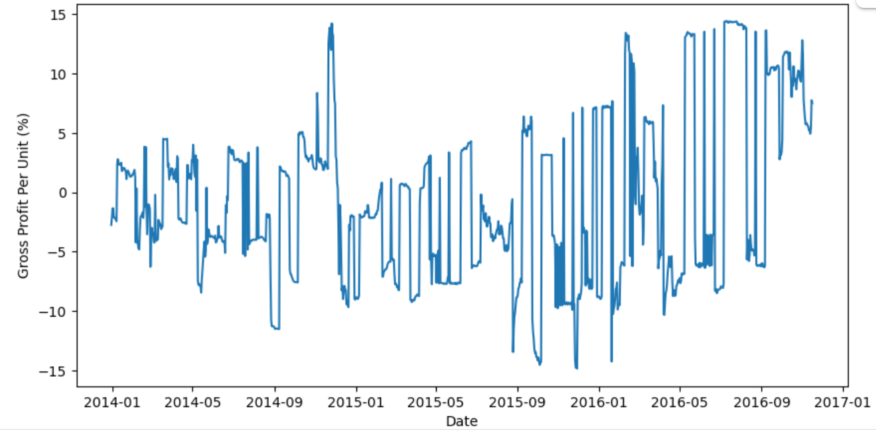

##### **PED** (Price Elasticity of Demand)

It measures how the quantity demanded of a good or service changes in response to a change in its price.

*If PED > 1, demand is considered elastic (consumers are highly responsive to price changes).*

*If PED < 1, demand is considered inelastic (consumers are less responsive to price changes).*

*If PED = 1, demand is unitary elastic (the percentage change in quantity demanded is equal to the percentage change in price)*

**PED** =

This code removes the unit and scale differences to be (1 and 0) between Quantity Sold and Price Per Unit by applying feature scaling. After normalization: A high quantity sold becomes closer to 1 and A low price per unit becomes closer to 0

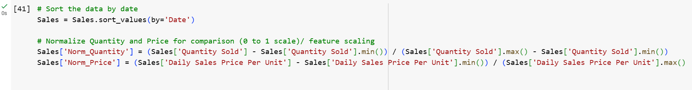

Computing Promo combines the two normalized metrics into one score(High quantity sold(close to 1) – good for the analysis and Low Price ( close to 0) therefore Promo score = High Norm Quantiy – Low Norm Price

The higher the promo score, the better the promotional effect

I picked the 3 periods where the Promo score is high

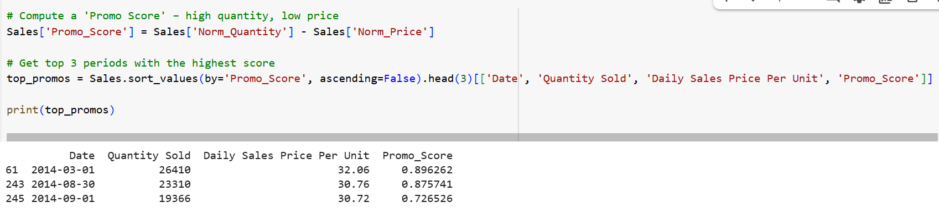

To visualize the 3 promo peaks

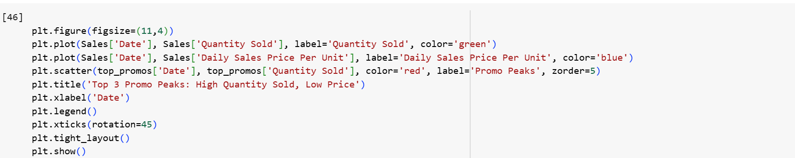

**Periods: 01 May 2014, 30 August 2014, 01 Sep 2014**

We see that Promotions drive higher quantity sold but have lower prices due to discounts.

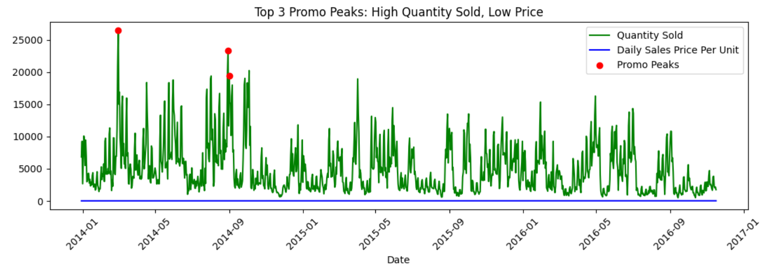

To extract the 3 periods from the dataset

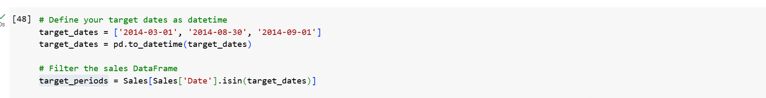

We have ( +PED) This means that the consumers are responsive to price

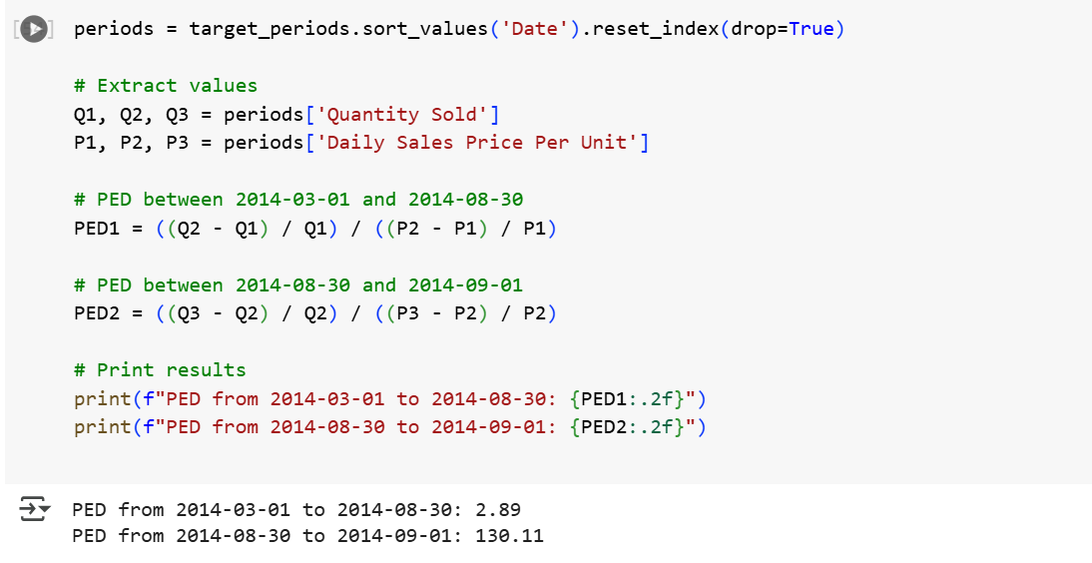

The PEDs are great than 1 and the Promo scores are all great than 5 this means that quantity sold and the sales went up during the Promotion period so the product performed better

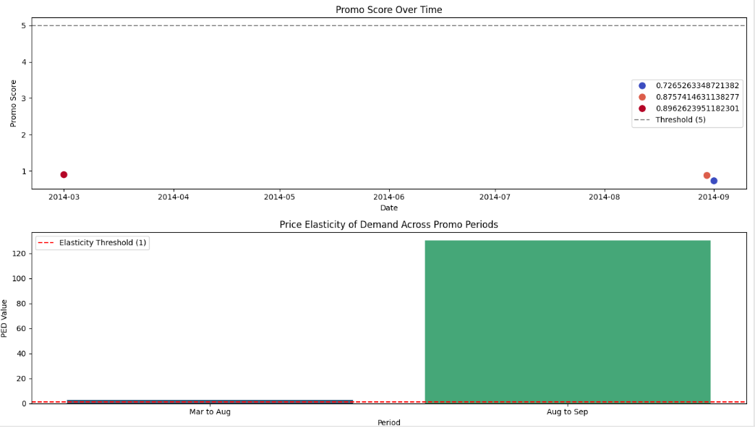

### 5. The Insights

Month-over-Month (MoM) achanges help track sales trends and performance over time

**MoM (%)** =

Calculated the mentioned measures using PowerBI

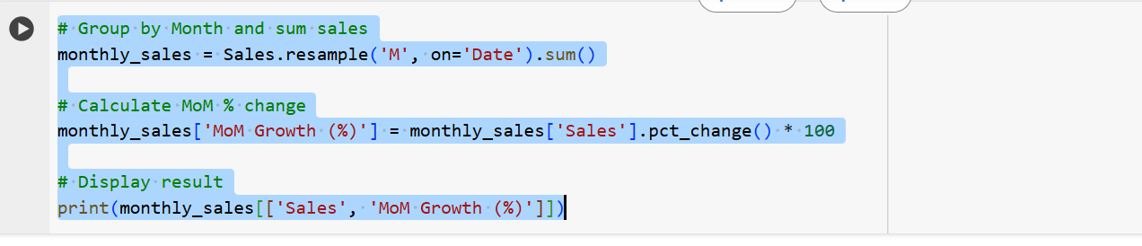

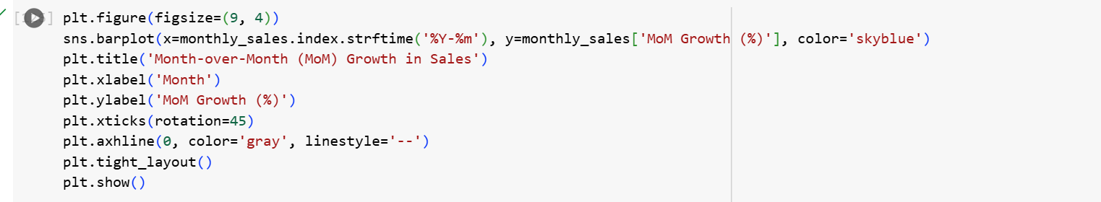

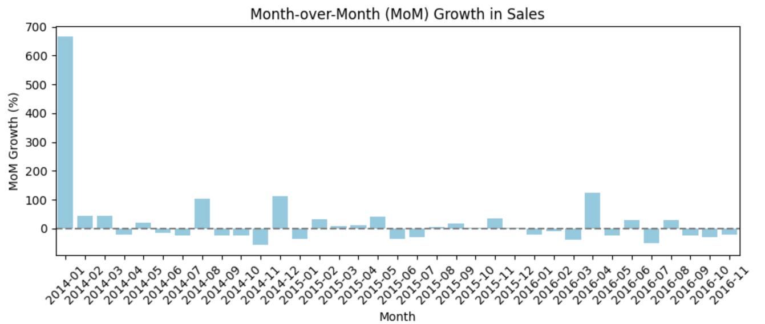

The Month-over-Month (MoM) analysis reveals a significant surge in sales during January, indicating strong consumer demand likely driven by post-holiday purchases

Conversely, April experienced a noticeable decline in sales, marking a period of negative MoM growth.

Despite monthly fluctuations in sales and profit, the overall performance shows strong upward momentum. With an **overall MoM Sales Growth of 24.43%** and **Profit Growth of 68.77%**, the product demonstrates high responsiveness to pricing and promotional strategies.